The thermal effect during microwave ablation treatment of Hepatocellular Carcinoma
Marija Radmilović-Radjenović, Nikola Bošković, and Branislav Radjenović
Institute of Physics Belgrade, University of Belgrade, Pregrevica 118, 11080 Belgrade, Serbia
Contact: M. Radmilović-Radjenović ( marija@ipb.ac.rs )
Abstract. Hepatocellular Carcinoma (HCC) accounts for more than 75% of all liver cancers representing the fourth major cause of cancer-related death [1]. One of the most persuasive treatments for HCC is microwave ablation (MWA) particularly recommended for COVID-19 patients with liver tumors as a minimally invasive procedure with a short recovery time. For this study, calculations were performed using the COMSOL Multiphysics software package based on the finite element method [2]. Simulation conditions include a 10-slots antenna operating at microwave frequency of 2.45 GHz, the input power of 10 W, and parameters corresponding to the liver tissue (healthy and tumoral) taken from ref. [3]. The antenna immersed into the tissue radiates energy that is converted into the heat invading the tissue (Fig. 1a). The absorbed energy converted into thermal energy leads to an increase in the tissue temperature (Fig.1b). The region where ∆T=T−T_{b} ≥15 ◦C (T_{b} is the blood temperature) is mainly located inside the tumor indicating a small risk of damaging healthy tissue (Fig. 1c). The damage zone is concentrated around the tip and slots of the antenna, while the backward heating effect is smaller as depicted in Fig. 1d.
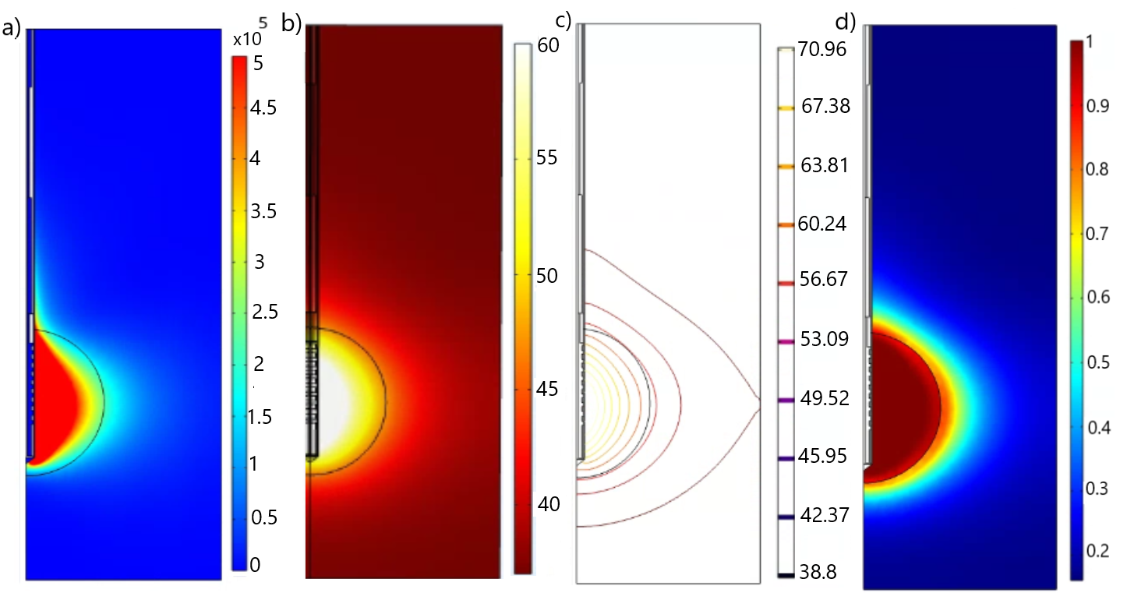
Figure 1. a) The total power dissipation density (expressed in W/m³). b) The temperature (expressed in °C) distributions in the liver tissue after 600 s of microwave ablation. c) Spatial distribution of (∆T=T−T_{b}). d) Fraction of necrotic tissue after 600 s of microwave ablation.
Acknowledgements. This research was supported by the Institute of Physics Belgrade, through the grant by the Ministry of Education, Science and Technological Development of the Republic of Serbia and by the Science Fund of the Republic of Serbia, GRANT 7739583, SimSurgery.
REFERENCES
- J.M. Llovet, R.K. Kelley et al. Nat. Rev. Dis. Primers 7 (2021), 6.
- Comsol Multiphysics. Available online: www.comsol.com
- B. Radjenović, M. Sabo et al., Cancers 13 (2021), 5784.

